Distance Learning Fees – Guidelines & Procedures
Contents
Distance Learning Fees – Guidelines & Procedures 1
Background 2
Guidelines 2
Distance Learning Course Fees 3
Security Role 3
Navigation 3
Creating Your Distance Learning Fee Request Form: 3
Additional Questions 10

Background
There has been statutory authorization for Distance Learning Fees since 2008. The original statute was modified in 2009 with the requirement that:

For purposes of assessing this fee, a distance learning course is a course in which at least 80 percent of the direct instruction of the course is delivered using some form of technology when the student and instructor are separated by time or space, or both. [F.S. 1009.24 (17)(a)].

The amount of the distance learning course fee may not exceed the additional costs of the services provided which are attributable to the development and delivery of the distance learning course. [F.S. 1009.24 (17)(b)].

Compliance with the statutory requirements has, by default, been delegated to the units responsible for course development and delivery. The following guidelines and procedures are in place to align with the statutory requirements.

Guidelines
- All requests for the Distance Learning Course Fee must pass the test of “additional costs of the service provided which are attributable to the development and delivery of the distance learning course.” In this respect:
- These are marginal costs at the section/class level, not the program level.
- These are costs for development and delivery, not for demand analysis and creation.
- The basic support costs for the students in such courses are paid through the tuition charge and other student fees.
- All expenditures of Distance Learning Course Fees must be for the purposes associated with this list of Fee Items:
  - Course Production
  - IT Support Costs
  - Online Proctoring
  - Course Captioning
- The following are examples of types of expenditures that are not eligible for such funding:
  - Advertising/marketing
  - OPS
  - Hardware - Depreciation Sch Req
  - Telephones
  - Travel
  - Food Budgets
- All salaries, benefits, and other personal services must be appropriately allocated to the relevant course. Any allocative protocol must be based on an acceptable joint or common cost standard.
- Development is generally an upfront cost. Any allocation beyond first presentation must represent an appropriate allocation of the useful life of the actual development.
- Self-Funded and UF Online Program courses are not eligible to charge DL Fees. These programs cover any additional costs out of their budgets.

Distance Learning Course Fees
The following instructions will walk you through the process of completing the online request for distance learning course fees. Before you begin, please review the Distance Learning Policies.

Security Role
You will need the role UF_DLFEE_REQUESTER to submit the Distance Learning Fee Form request.
For Dean’s Office approvers they will need the role UF_SF_DLFEE_DEAN_APPR.
The same person cannot have both roles.

Navigation
Login into myUFL and navigate to:
Nav Bar > Main Menu > Student Information System > Student Financials > Tuition and Fees > Class/Fee Request > Distance Learning Fee Request

Creating Your Distance Learning Fee Request Form:
- Click the Add a New Value tab.
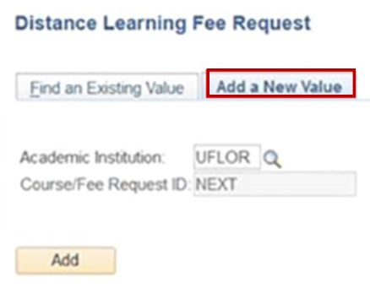

- Select the Add button to start a new request form.
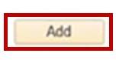

Note: If you already have a form saved, use the Find an Existing Value field to find your saved form.

- If you wish to use data from a previous term DL Fee form, simply enter the seven-digit form number into the Copy From Request ID.

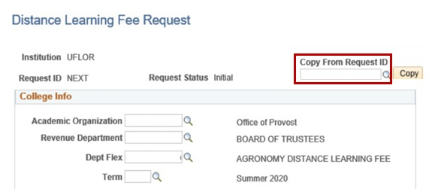

- Click the Copy button and your form should populate with data from the previous form.
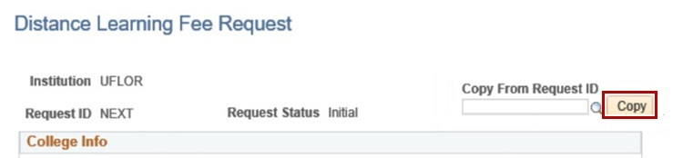
Note: Be sure to update the term and click the save button. This will generate a new form number and save your data.

- Enter the Academic Organization, the department responsible for the course or the Dean’s Office that will be in the approval path.
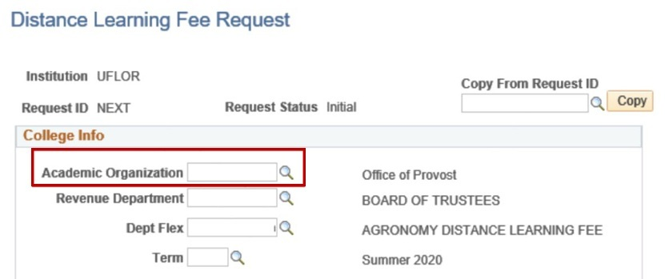
- Enter the Revenue Department. The Revenue Department is the department that will be used on the General Ledger transactions to deposit the money.
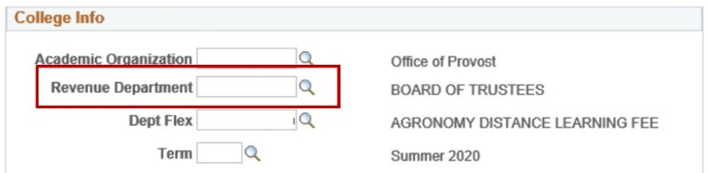

- Enter the Department Flex number. This is the 52XXXX number for the specific account that you wish for your distance learning fee to deposit the revenues into. If you do not know what this number is check with your finance contact for your department or college.
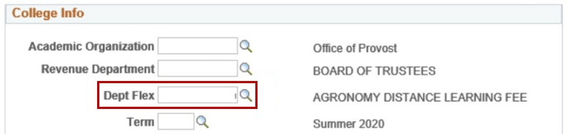

- Enter the four-digit Term.
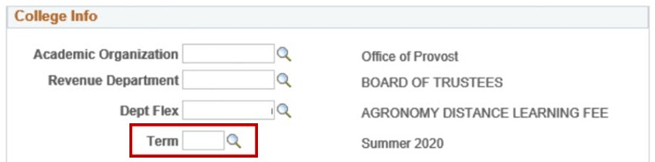

- Enter your Contact Information (UF ID Number).
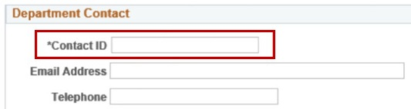

- From the Fee Category drop down, select Fee items.
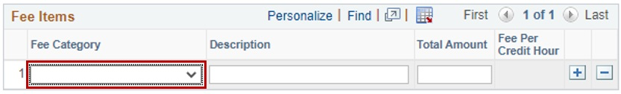

- Add a Description for the item.
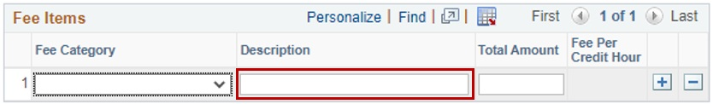

- List total costs for the item in the Total Amount field.
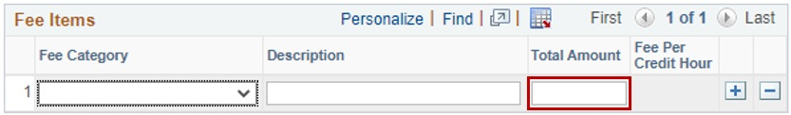

- Use the Plus (+) icon to add another row for another fee item.
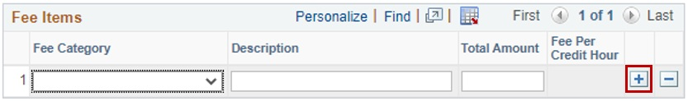

- Enter course prefix/number in the Course field.
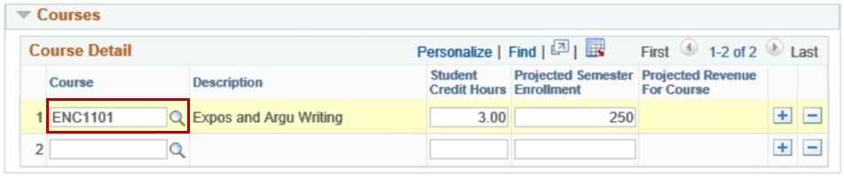

- Enter the credit hours in the Student Credit Hours field.
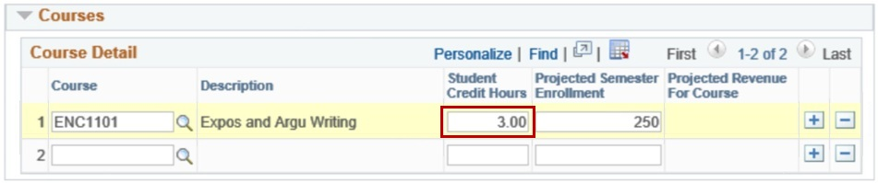

- Enter the projected enrollment information in the Projected Semester Enrollment field.
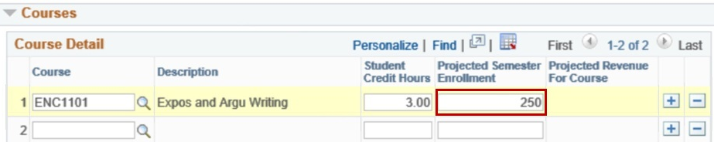

- List all courses that will offer a section/class online that will incur the additional costs. You should not create a new form for each course unless a course or group of courses have different costs. You can create different forms if you have courses at different per credit hour amounts. Use the Plus (+) icon to add another row and course.
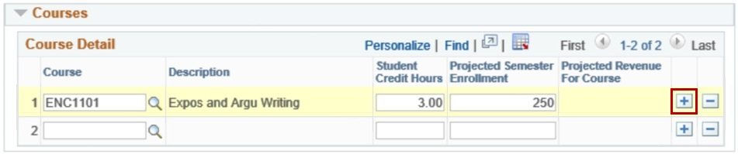

- The per credit hour DL Fee is calculated from the information you enter on the form.
(Costs, courses, credit hours, enrollments projections)
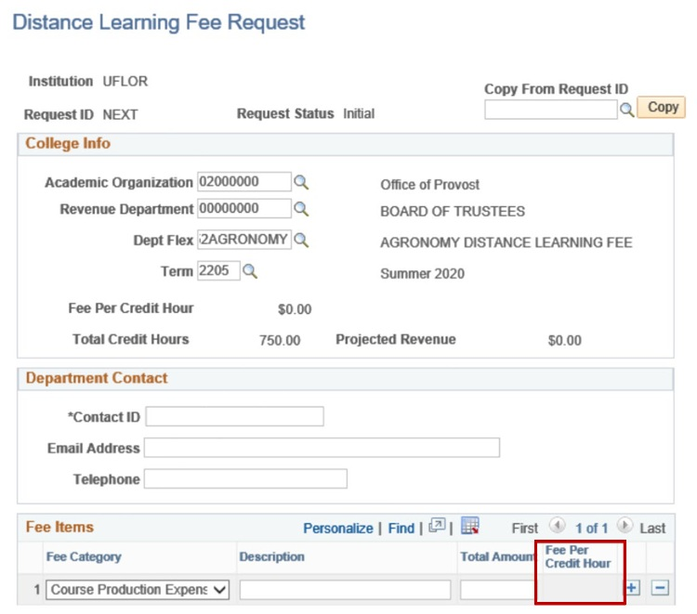
- In the justification fields, enter your justification for each of the questions about your distance learning fees.
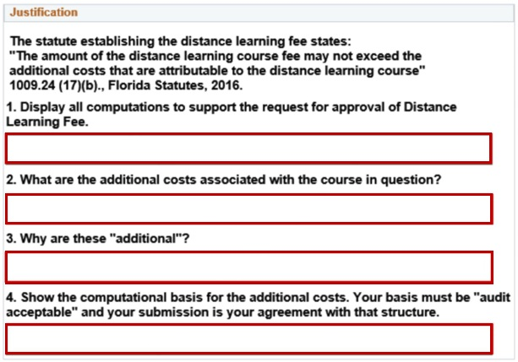

Note: You can save your form without anything entered in the justification fields however when you are ready to submit your form for Dean’s Level Approval you will receive an error if you do not have something entered in all three of the fields below.

- Enter any additional comments in the Comments field.
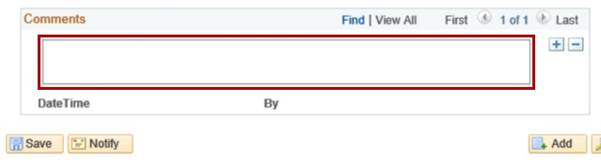
- Always be sure to click the Save button at the bottom of the page before you leave the screen to ensure that your data is saved.

- When the form is complete click the Submit for Approval button at the bottom. The form will then go to the Dean’s Office approver. When they approve the form, it moves on for final approval from the Office of Teaching and Technology.
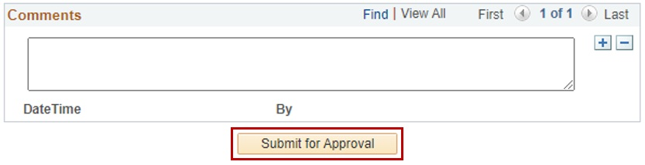

Additional Questions
For assistance with processes or policies related to Distance Learning Course Fees, contact:
Office of Teaching and Technology Support Services
Email: cnewsom@ufl.edu
Phone: 352-294-0851

