November 2025

Side Angle Camera Guidelines for online Proctoring

Side Angle Camera Assessment
Honorlock supports the use of a side-angle camera to enhance exam monitoring. This setup provides a wider view of the test taker's workspace, including hands, keyboard, and surrounding area.

Required Syllabus Statement if the use of a side angle camera is being used for assessment in a course
Include the following in your course syllabus:
- Online proctoring using Honorlock will be required for this course.
- You will be required to use a side-angle camera or your front-facing camera during exam assessment. Your cell phone can be used as the side-angle camera.

For the instructor:
- If a student does not have access to a side angle camera, an alternative assessment option must be provided.
- One alternative would be to create a separate exam for the student that does not require a side angle camera.

Equipment Needed
Computer (Windows or Mac) with a front-facing-camera. This is a UF requirement for all students.
External webcam or smartphone to be used as a side-angle camera.
Well-lit testing area

Note: Honorlock is incompatible with:
- iPads
- Amcrest Cameras
- Walmart/Onn Branded Cameras
- Nexigo Cameras

Recommended: Tripod or gooseneck mount, USB extension cable

Using Your Smartphone as a Webcam
- iPhone: Use Continuity Camera with the latest macOS.
- Android: Use Webcam Mode with the latest Android version on Windows or macOS.
- Third-party apps (if needed): Camo or EpocCam.
Tip: Use a wired connection (USB) instead of Wi-Fi for better reliability.

SEtup instructions
Step 1: Prepare Your Space
- Choose a quiet, well-lit location.
- Clear your desk of clutter.
- Ensure space for your computer and any allowed materials.
Step 2: Position the Camera
- Place the camera about 3 feet to your side.
- A quick method: stretch your arm out to the side—place the camera where your fingertips reach.
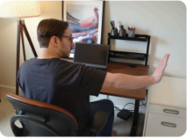
Step 3: Mount the Camera
- Use a tripod, gooseneck mount, box, or shelf.
- Ensure your head, hands, keyboard, and screen are visible.
Step 4: Connect the Camera
- Plug the camera into your computer or connect camera through Bluetooth.
- Use a USB extension cable if needed (i.e., if you are not connecting wirelessly).
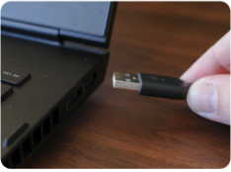
Step 5: Adjust the View
- Use the on-screen overlay to align the camera (this should appear automatically)
- Confirm visibility of your face, hands, keyboard, screen, and allowed materials.
- Use your computer’s camera preview to double-check.
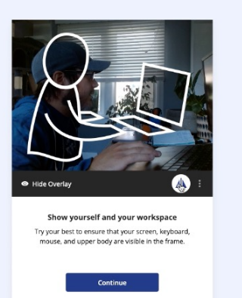

Step 6: You're Ready!
- Begin your exam once setup is complete.

Support and Resources
- Setup Guide: Honorlock Side-Angle Camera Setup
- Technical Support: Honorlock Support

